Router top module code and waveform – Raja Aadhithan.

RTL:

module router_top(input clock, resetn, read_enb_0, read_enb_1, read_enb_2, pkt_valid,

                  input [7:0] data_in, output [7:0] data_out_0, data_out_1, data_out_2,

                  output valid_out_0, valid_out_1, valid_out_2, error, busy);

wire parity_done,detect_add;

wire ld_state, laf_state, full_state, write_enb_reg, rst_int_reg, lfd_state;

wire [2:0] fifo_empty, full,w_enb, write_enb, soft_reset_temp;

wire fifo_full,low_pkt_valid,soft_reset_0,soft_reset_1,soft_reset_2;

wire [7:0] dout;

wire read_enb_temp[2:0];

wire [7:0] data_out_temp[2:0];

assign soft_reset_temp[0] = soft_reset_0;

assign soft_reset_temp[1] = soft_reset_2;

assign soft_reset_temp[2] = soft_reset_1;

assign read_enb_temp[0] = read_enb_0;

assign read_enb_temp[1] = read_enb_1;

assign read_enb_temp[2] = read_enb_2;

assign data_out_0 = data_out_temp[0];

assign data_out_1 = data_out_temp[1];

assign data_out_2 = data_out_temp[2];

router_fsm dut1(.clock(clock),

                .resetn(resetn),

                .pkt_valid(pkt_valid),

                .parity_done(parity_done),

                .soft_reset_0(soft_reset_0),

                .soft_reset_1(soft_reset_1),

                .soft_reset_2(soft_reset_2),

                .fifo_full(fifo_full),

                .low_pkt_valid(low_pkt_valid),

                .fifo_empty_0(fifo_empty[0]),

                .fifo_empty_1(fifo_empty[1]),

                .fifo_empty_2(fifo_empty[2]),

                .data_in(data_in[1:0]),

                .busy(busy),

                .detect_add(detect_add),

                .ld_state(ld_state),

                .laf_state(laf_state),

                .full_state(full_state),

                .write_enb_reg(write_enb_reg),

                .rst_int_reg(rst_int_reg),

                .lfd_state(lfd_state));

router_reg dut2(.clock(clock),

                .resetn(resetn),

                .pkt_valid(pkt_valid),

                .fifo_full(fifo_full),

                .detect_add(detect_add),

                .ld_state(ld_state),

                .laf_state(laf_state),

                .full_state(full_state),

                .rst_int_reg(rst_int_reg),

                .lfd_state(lfd_state),

                .parity_done(parity_done),

                .low_pkt_valid(low_pkt_valid),

                .err(error),

                .data_in(data_in),

                .dout(dout));

router_sync dut3(.clock(clock),

                .resetn(resetn),

                .detect_add(detect_add),

                .read_enb_0(read_enb_0),

                .read_enb_1(read_enb_1),

                .read_enb_2(read_enb_2),

                .write_enb_reg(write_enb_reg),

                .empty_0(fifo_empty[0]),

                .empty_1(fifo_empty[1]),

                .empty_2(fifo_empty[2]),

                .full_0(full[0]),

                .full_1(full[1]),

                .full_2(full[2]),

                .data_in(data_in[1:0]),

                .vld_out_0(valid_out_0),

                .vld_out_1(valid_out_1),

                .vld_out_2(valid_out_2),

                .soft_reset_0(soft_reset_0),

                .soft_reset_1(soft_reset_1),

                .soft_reset_2(soft_reset_2),

                .fifo_full(fifo_full),

                .write_enb(w_enb));

genvar x;

generate for (x= 0 ; x<3 ; x = x+1)

begin:fifo

    router_fifo f(.clock(clock),

                  .resetn(resetn),

                  .soft_reset(soft_reset_temp[x]),

                  .lfd_state(lfd_state),

                  .write_enb(w_enb[x]),

                  .data_in(dout),

                  .read_enb(read_enb_temp[x]),

                  .full(full[x]),

                  .empty(fifo_empty[x]),

                  .data_out(data_out_temp[x]));

end

endgenerate

endmodule

Test bench:

module router_top_tb();

reg clock, resetn, read_enb_0, read_enb_1, read_enb_2, pkt_valid;

reg [7:0] data_in;

wire [7:0] data_out_0, data_out_1, data_out_2;

wire valid_out_0, valid_out_1, valid_out_2, error, busy;

integer i;

router_top dut(clock, resetn, read_enb_0, read_enb_1, read_enb_2, pkt_valid,data_in,

               data_out_0, data_out_1, data_out_2, valid_out_0, valid_out_1, valid_out_2, error, busy);

initial begin

    clock = 1;

    forever #5 clock = !clock;

end

task reset();

begin

    @(negedge clock);

    resetn =1'b0;

    #10;

    resetn = 1'b1;

end

endtask

task pkt16();

reg [7:0] parity;

reg [5:0] payload_len;

begin

    wait(!busy);

    begin

        @(negedge clock);

        payload_len = 6'b001110;

        pkt_valid = 1'b1;

        data_in = {payload_len,2'b10};

        parity = data_in;

    end

    for(i=0 ; i < payload_len; i=i+1 )

    begin

        wait(!busy)

        @(negedge clock)

        data_in = i*2;

        parity = parity^data_in;

    end

    wait(!busy);

    @(negedge clock)

    pkt_valid = 1'b0;

    data_in = parity;

    repeat(30)

    @(negedge clock);

    data_in = 8'bx;

    read_enb_2 = 1'b1;

end

endtask

initial begin

    reset;

    pkt16;

    #1000;

    $finish;

end

endmodule

WAVE (packet 14):

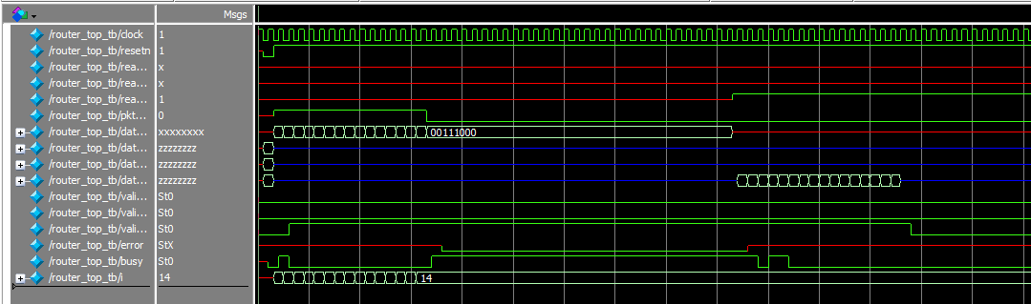 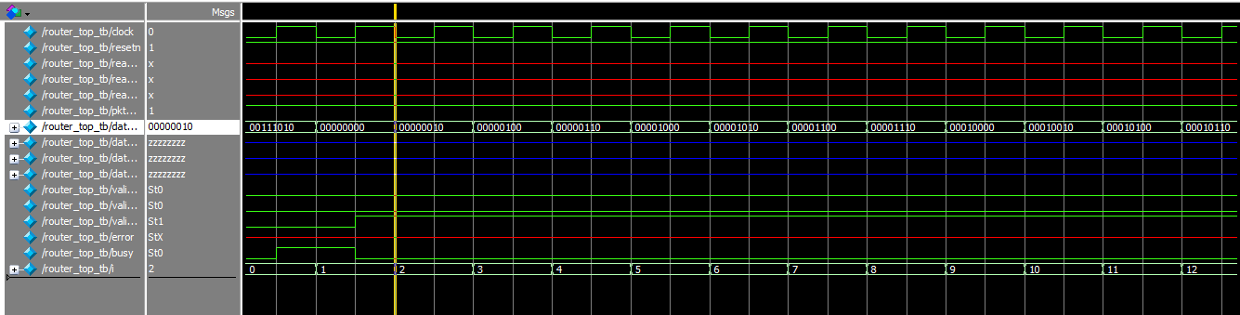 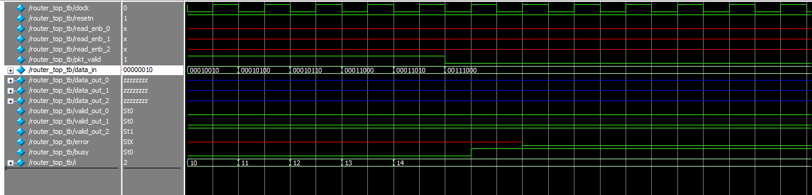 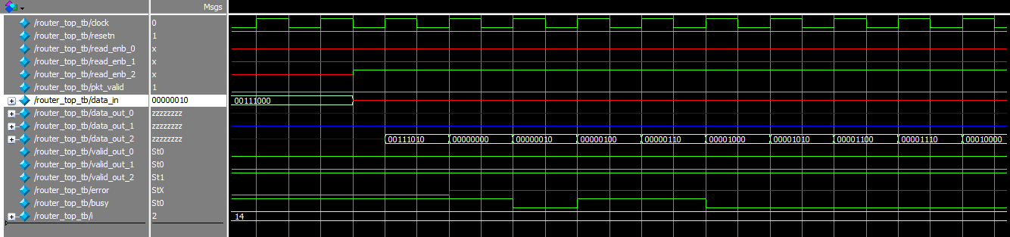 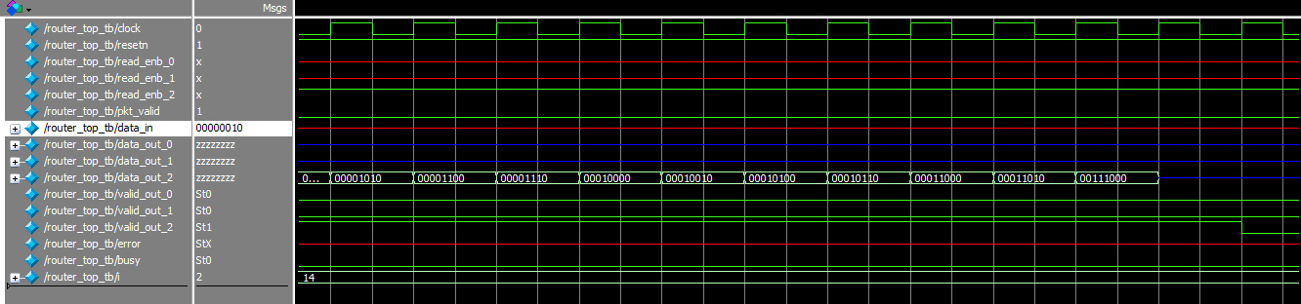

WAVE (packet 16):

